## **Elton Lim**

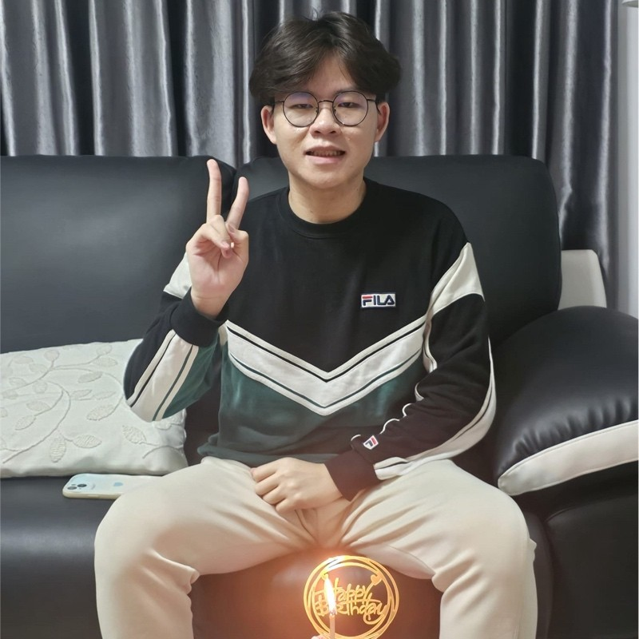

**“What you think, you become.”**

Business Student at Ngee Ann Polytechnic | School of Design & Environment | Currently pursuing a diploma in Real Estate Business📖 | Minor in Entrepreneurship

**Executive Summary**

I am a dedicated and driven student currently pursuing a Diploma in Real Estate Business at Ngee Ann Polytechnic, with a Minor in Entrepreneurship. Throughout my academic journey, I have consistently demonstrated strong leadership, critical thinking, and problem-solving skills. My involvement in various co-curricular activities, such as ShowChoir, the Korean Culture Club, and the DE Green Group, has allowed me to develop excellent teamwork, communication, and organizational abilities. With a passion for real estate and business, I have gained valuable experience through part-time roles in customer service and event coordination, refining my skills in communication, service delivery, and project management. I am committed to personal and professional growth and am eager to contribute my knowledge and skills in a dynamic real estate environment. Driven by a positive mindset and a dedication to excellence, I am focused on achieving my academic and career goals while making a meaningful impact in my community and beyond.

**About**

Business Student at Ngee Ann Polytechnic | School of Design & Environment | Currently pursuing a diploma in Real Estate Business🥰📖 | Minor in Entrepreneurship | Ngee Ann polytechnic DE Green Group 🍀 ShowChoir 🎤 & Korean Culture Club🩷|

## **My Work Experience**



**Resturant Server**

Violet Oon Inc Pte Ltd · Part-time

Mar 2025 - Present · 11 mos

Singapore · On-site

Restaurant Server | Violet Oon Singapore, National Kitchen As a Restaurant Server at Violet Oon Singapore’s National Kitchen outlet, I provided attentive and personalized service in a high-end Peranakan dining environment. My responsibilities included welcoming guests, presenting menus with in-depth knowledge of Peranakan cuisine, taking orders, and ensuring a seamless dining experience from start to finish. I collaborated with the front-of-house team to uphold service excellence, maintained a polished and professional demeanor, and handled guest requests efficiently in a fast-paced, upscale setting. Through this role, I honed my communication, multitasking, and customer service skills while deepening my appreciation for Singapore’s culinary heritage.

[**Service Delivery**](https://www.linkedin.com/in/elton-lim-b12690308/#)

**Room Service Attendant**

W Hotel Management and Services · Part-time

Oct 2023 - Nov 2023 · 2 mos

Singapore · On-site

A room service job typically involves delivering food and beverages to guests in a hotel, ensuring a high standard of service, and maintaining guest satisfaction Job Title:Room Service Attendant Reports to:Room Service Manager/Hotel Manager Job Summary: I was responsible for delivering food and beverages to guests in their rooms in a timely and professional manner. I ensure that guests have a pleasant dining experience in their rooms and address any needs or concerns promptly. Key Responsibilities: 1. Food and Beverage Delivery: - Deliver food and beverages to guest rooms promptly and courteously. - Ensure that orders are accurate and presented attractively. - Set up room service tables and trays according to hotel standards. 2. Guest Interaction: - Greet guests in a friendly and professional manner. - Address guest inquiries and provide information about menu items. - Handle guest complaints and concerns, ensuring they are resolved promptly and to the guest’s satisfaction. 3. Order Taking: - Answer room service phone calls and take guest orders accurately. - Provide menu recommendations and upsell additional items. 4. Setup and Cleanup: - Set up room service trays and tables with appropriate dishes, silverware, and condiments. - Collect used trays and dishes from guest rooms and corridors. - Maintain cleanliness and organization of room service areas and equipment. 5. Coordination with Kitchen and Other Departments: - Communicate effectively with the kitchen to ensure timely preparation of orders. - Coordinate with housekeeping and front desk for special requests and guest needs. 6. Compliance and Safety: - Follow all health and safety regulations and hotel policies. - Maintain hygiene and cleanliness standards in food handling and service.

[**Room Service and Service Delivery**](https://www.linkedin.com/in/elton-lim-b12690308/#)



**Promoter**

Red Bull · Part-time

Jan 2023 - Apr 2023 · 4 mos

Singapore · Remote

Duration (02/2023 – 04/2023) Name of Company: Allswell Trading Singapore Job Designation : • As a brand promoter, my role is to increase awareness and drive engagement with a specific brand. This involves implementing marketing strategies, conducting product demonstrations, and interacting with potential customers. Promoters often attend events, distribute promotional materials, and use various channels to positively represent and enhance the brand image. Effective communication and a deep understanding of the brand's values and products are crucial for success in this role.

[**Customer Service, Marketing and +1 skill**](https://www.linkedin.com/in/elton-lim-b12690308/#)



**Banquet Server**

Capella Hotels and Resorts · Full-time

Oct 2022 - Feb 2023 · 5 mos

Singapore · On-site

Duration (10/2022 – 02/2023) Name of Company: Capella Hotel Job Designation : • Banquet job involves coordinating and executing events, such as weddings or corporate functions. Responsibilities may include setting up venues, managing staff, ensuring guest satisfaction, and overseeing event logistics. Strong organizational and communication skills are typically required. • In Room Dining position involves delivering food and beverages to guests in their rooms, processing orders, and maintaining a high level of customer service. Responsibilities may include taking orders over the phone, ensuring accuracy in food preparation, and coordinating with kitchen staff. Excellent communication and customer service skills are essential for this role. Spoken Language : English and Chinese Written Language : English and Chinese

|  |  |
| --- | --- |
|  |  |

[**Team Leadership and Customer Service**](https://www.linkedin.com/in/elton-lim-b12690308/#)

## **My Education Journey**



**Ngee Ann Polytechnic**

Diploma of Education, Real Estate

Apr 2024 – Apr 2027

Grade: Current GPA: 4.0

Activities and societies: CCAs: - ShowChoir - Korean Culture Club - NP Amplify (Song Composing) Community Service: - Blossom World Society - NP Green Group (EXCO Committee Admin Head) - Taman Jurong Zone F Resident Network - NP Leo Club - NP FoodAid - NP Rotaract

Awards & Achievements - Minor in Global Readiness - Minor in Entrepreneurship - Director’s List for Excellent Academic Performance in Levels 1.2, 2.1 - Most Outstanding Performance: 1.2 - Distinctions in: ENVIRONMENTAL SERVICES & WORKPLACE SAFETY, CONFIDENT COMMUNICATION: FIND YOUR VOICE, INNOVATION MADE POSSIBLE, PRINCIPLES OF LAW - DEX Hackathon (Overall Winner) - Overseas Immersion Programme (OIP): Wuhan, China - Youth Expedition Programme (YEP): Yogyakarta, Indonesia

[**Leadership, Data Analysis and +4 skills**](https://www.linkedin.com/in/elton-lim-b12690308/#)

**Juying Secondary School**

O-Levels , Biology/Biological Sciences, General

Jan 2019 – Dec 2022

Grade: L1R5: 13

Activities and societies: Co-Curriculum activities: Show Choir - B-Dazzled Annual Music, Dance & Show Choir festival - Show Choir Singapore Youth Festival (SYF)

Ordinary Level Cambridge Examination: English Language Chinese Language Pure Chemistry Pure Biology Additional Mathematics Elementary Mathematics Combined Social Studies + Geography

**Skills:** Leadership

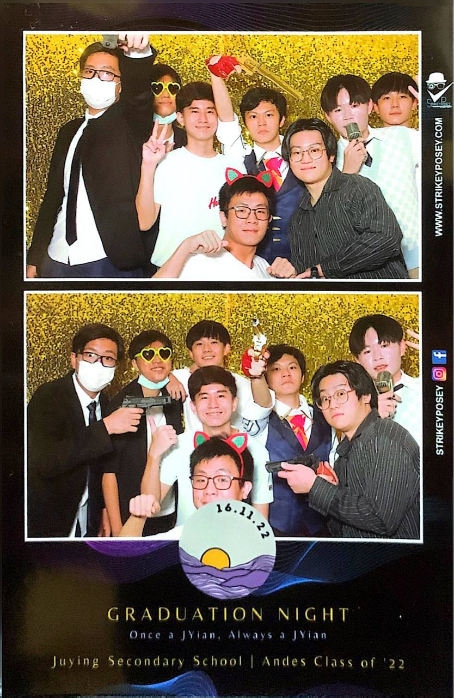

**Skills**

**Data Analysis**



Ngee Ann Polytechnic

**Accounting**



Ngee Ann Polytechnic

**Financial Analysis**



Ngee Ann Polytechnic

**Business Analysis**



Ngee Ann Polytechnic

**Room Service**

**Service Delivery**



[2 experiences at Violet Oon Inc Pte Ltd and 1 other company](https://www.linkedin.com/in/elton-lim-b12690308/details/skills/#)

**Marketing**



Promoter at Red Bull

**Direct Sales**



Promoter at Red Bull

**Customer Service**



[2 experiences at Red Bull and 1 other company](https://www.linkedin.com/in/elton-lim-b12690308/details/skills/#)

**Leadership**



[2 educational experiences at Ngee Ann Polytechnic and 1 other school](https://www.linkedin.com/in/elton-lim-b12690308/details/skills/#)

**Project Work**



Millennia Institute

**Team Leadership**



Banquet Server at Capella Hotels and Resorts



[2 educational experiences at Ngee Ann Polytechnic and 1 other school](https://www.linkedin.com/in/elton-lim-b12690308/details/skills/#)

**Volunteer Organizations**

**Green Group**

EXCO Committee (Admin Head) · Mar 2025 – Present



Associated with Ngee Ann Polytechnic

Green Group Committee Exco Member (Admin Head) As the Admin Head of the Green Group Committee, I am responsible for overseeing administrative operations, ensuring smooth coordination and communication within the team. My role includes managing documentation, organizing meetings and events, and maintaining accurate records to support our sustainability initiatives. I work closely with fellow exco members to plan and implement green projects that promote environmental awareness and sustainable practices within the community.

|  |  |
| --- | --- |
|  |  |
|  |  |

**Ngee Ann Polytechnic x National Youth Corps**

**YEP – Youth Expedition Programme (Indonesia, Yogyakarta)**

During my Youth Expedition Programme (YEP) trip to Yogyakarta, Indonesia, I had the opportunity to engage in meaningful community service and cultural immersion. The experience allowed me to contribute to various local initiatives, including supporting rural schools and interacting with underserved communities. It was incredibly eye-opening to witness the daily lives of the people in Yogyakarta and to understand their resilience and warmth. The trip not only broadened my cultural perspective but also enhanced my empathy and teamwork skills, as we worked alongside local volunteers to create a positive impact. It was a fulfilling journey that deepened my appreciation for community service and the value of cross-cultural connections.

|  |  |
| --- | --- |
|  |  |
|  |  |
|  |  |
|  |  |
|  |  |

**Blossom World Society**

EXCO Committee Member (Logistics Head) · Oct 2024 – Present

Blossom Home Refresh by Blossom World Society Blossom Home offers decluttering and basic cleaning services specially designed to support seniors in maintaining a safe, clean, and comfortable living environment. Our dedicated volunteers provide gentle assistance with organizing personal spaces, removing clutter, and carrying out light housekeeping tasks. By creating a more orderly and hygienic home, we aim to enhance the well-being, independence, and quality of life of our elderly clients—allowing them to age with dignity in a space they feel proud of.

|  |  |
| --- | --- |
|  |  |
|  |  |
|  |  |
|  |  |

**Taman Jurong Passion Assosiation**

Volunteer · Jan 2017 – Present

Volunteer | Passion Association Duration (Jan 2017 – Present) At Passion Association, I volunteered as part of a youth-led team dedicated to supporting vulnerable communities through compassion and consistent action. I assisted in various community outreach programmes such as welfare distributions, donation drives, and home visitations to engage with seniors and low-income families. My responsibilities included helping with logistics coordination, interacting with beneficiaries, ensuring smooth event flow, and contributing ideas to make each initiative more meaningful and impactful. Through this experience, I developed stronger communication and teamwork skills, while gaining a deeper appreciation for empathy, community engagement, and social responsibility. This experience reinforced my belief in the power of youth-led service — that small acts of kindness, when done with sincerity, can create lasting positive change in the community.

|  |  |
| --- | --- |
|  |  |
|  |  |
|  |  |
|  |  |

**Resume:**

|  |  |  |
| --- | --- | --- |
| **Lim Jia Yu, Elton**  [Eltonlimjy@gmail.com](mailto:Eltonlimjy@gmail.com) | (+65) 82381939  [www.linkedin.com/in/elton-lim-b12690308](https://www.linkedin.com/in/elton-lim-b12690308) | <https://honey-scarer-822.notion.site/Lim-Jia-Yu-Elton-Digital-Portfolio-2aea33c3a79580d392b0fe9c45678673?source=copy_link> |  |  |
| **OBJECTIVE**  I am a graduating student pursuing a Diploma in Real Estate Business at Ngee Ann Polytechnic, with a strong foundation in valuation, property management, real estate law, and financial analysis. Through both coursework and leadership roles, I have developed the ability to analyze property-related information, coordinate stakeholders, and communicate clearly in fast-paced environments.  Outside of my studies, I have organized events such as a bonding camp for my CCA, inter-school games, orientation, and leadership camps. These experiences have equipped me to work well in teams, persevere amidst adversity, and resolve problems.  I am seeking an internship position in the real estate sector to apply my skills in property and facilities management, support day-to-day operations, and contribute to the achievement of organizational and business objectives. |  | **TRAITS & SKILLS**   * Diligent and responsible * Organised and systematic * Team player * Able to work independently * Work well under pressure * Proactive and solution-oriented * Positive, resilient growth mindset |
|  | **Software knowledge**   * Microsoft Office * Tableau * AutoCAD * Revit * Canva * Google Apps * Notion * Microsoft Teams |
| **education**  **Diploma in REAL ESTATE** Apr 2022 – May 2025  **business**  Ngee Ann Polytechnic (CGPA: 3.87)  Key completed modules:   * Valuation * Property Management * Real Estate Marketing * Real Estate Law * Principles of Law * Financial Accounting & Management * Economics * Global Business & Entreprenuership * Data Analytics for Market Research * Environmental Workplace Safety   **GCE ‘O’ Levels** Jan 2018 to Dec 2021  Juying Secondary School (L1R4: 11) | **LANGUAGEs**  * English (Native) * Chinese (Advanced Level)  **AWARDs & Achievements**  * Director’s List for Excellent Academic Performance (Levels 1.2 & 2.1), Ngee Ann Polytechnic * Edusave Merit Bursary Award (2021, 2024, 2025) * DEX Hackathon – Overall Winner (Food waste to compost business idea) |
| **CO-CURRICULAR ACTIVITIES**  Ngee Ann Polytechnic  DE GREEN GROUP APR 2024 - PRESENT   * EXCO Admin Head   Apr 2022 - Present   * Logistics Sub-Committee * NDP Performance & Musical Festivals   Apr 2022 - Present   * Committee Member   Juying Secondary School  Jan 2019 – Dec 2021   * B-dazzled Silver (2nd Place) * Singapore Youth Festival (SYF) Distinction   Jan 2018 – Dec 2020   * Logistics |  | **REFERENCES** **Mr. Alfred Tan**  Senior Advisor (Student Development)  School of Design & Environment  Ngee Ann Polytechnic  Telephone Number: 6460 8084  Email Address: [Alfred_TAN@np.edu.sg](mailto:Alfred_TAN@np.edu.sg)  **Mr. Tan Kok Ling**  Course Chair  Diploma in Real Estate Business  School of Design & Environment  Ngee Ann Polytechnic  Telephone Number: 6460 8972  Email Address: [TAN_Kok_Ling@np.edu.sg](mailto:TAN_Kok_Ling@np.edu.sg) |

**Award certificates:**

